Results Discussion
Basic Material – Part 1: Predicted Value/ Std. Pred Value/ Residual / Std. Residual
V217, GNP/CAP Growth Rate 1980-91, was regressed on V222, Industrial Growth Rate 1980-91, and an R-square of .58 was generated with an F-statistic of 57.198 significant at the P<.001 level. Residual statistics for this regression were generated, seen below. The following code was used to generate the results:
REGRESSION
/VARIABLES= V57 V210 V222 V223 V217
/DEPENDENT=V222
/METHOD=ENTER V217
/RESIDUALS=DEFAULTS ID(V1) OUTLIERS (ZRESID COOK)
/SCATTERPLOT (V222 V217) (*RESID V217) (*RESID *PRED) (*ZRESID *ZPRED).
The Predicted Value statistics provides the range of values the model predicts for the dependent variable (DV). Negative values indicate cases falling below the predicted line while positive values indicate case scores above the predicted line.
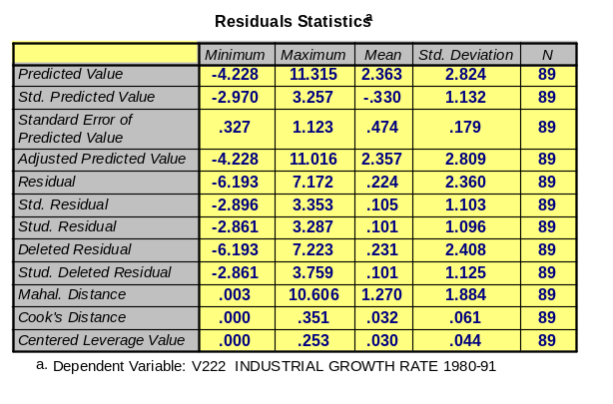
The Std (standardized) Predicted Value is the conversion of the predicted values to have a mean of zero and a standard deviation of 1. With the minimum score being –2.97 and the maximum score being 3.257 this indicates countries more than three standard deviations from the mean. These scores are often graphed against the standardized residuals to assess normality assumptions.
The Residual statistic is the difference between an observed value and the value predicted by the model. These values should be approximately normally distributed and show no pattern when plotted against the predicted values. These values can
not be used to compare relative size of one case to
another (SPSS 9.0 Guide to Data Analysis, pg433). However,
the Standardized Residuals can be used to compare
relative size as they have a mean of zero and a standard deviation of 1.
Considering the values of my standardized predicted values and standardized residuals, the model is likely influenced by the presence of outliers.
Basic Material – Part 2: Outlier Statistics
The Outlier Statistics table generated, next page and also in appendix page 4, illustrate the Standardized Residual and the Cook’s Distance statistic. The Standardized Residual section displays the largest outlier case while Cook’s Distance displays influential cases. These statistics should not be utilized until the residuals are assessed for normality and linearity as data transformations can result in different outlier and influential cases. Acknowledging this point, we initially find case 121 as potentially being an outlier an influential case. Both and outlier and an influential is in part determined by the amount of jump in one case’s statistic to the next. While a jump of .5 to 3 in the Cook’s Distance would clearly by influential, a jump from .273 to .351 (circled below) may not distinguish case 121 as an influential case. There seems to be enough evidence to support that case 121 is likely both
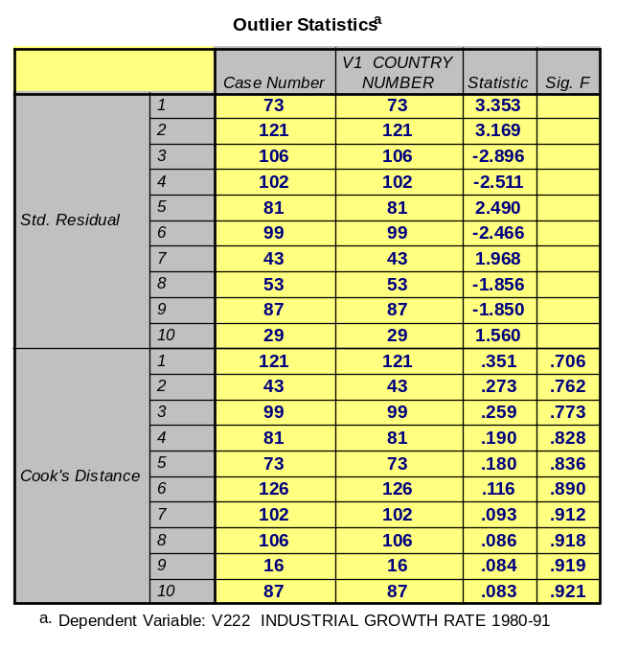
an outlier and influential case. Case 73 is
potentially being considered an outlier and
case 43 is being an influential case. A review
of changes in the R-square after these cases
were removed would contribute to a better
understanding of whether to keep or remove
them.

Basic Material – Part 3: Normality and Linearity Assessment
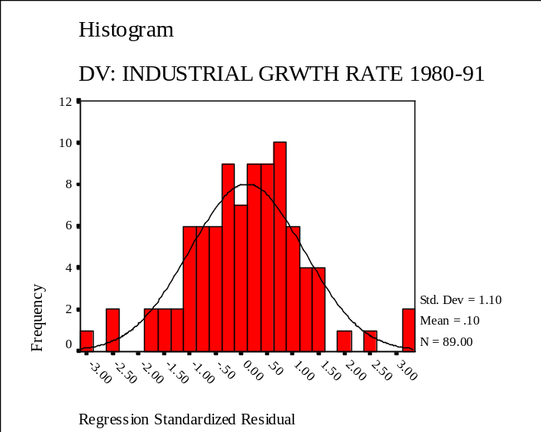
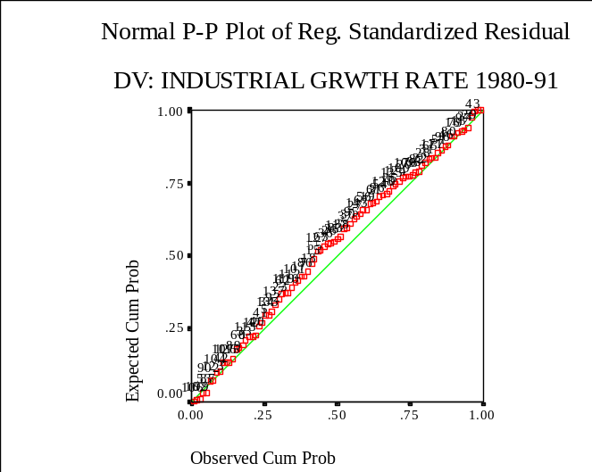
The following are the histogram and normal probability plot from the variables:
This histogram is used to assess the normality of the residuals and it appears quite normal. It seems that approximately 95% of the residuals are within +/- 2 standard deviations while also indicating the presence of outliers past three standard deviations. The normal probability plot has a slight rise above the linear line in the middle but no severe skewness in the data is apparent. As such, the R-square of .58 stands solid when considering the initial residual analysis.
Basic Material – Part 4: Variables Requiring Transformation / Residual Analysis
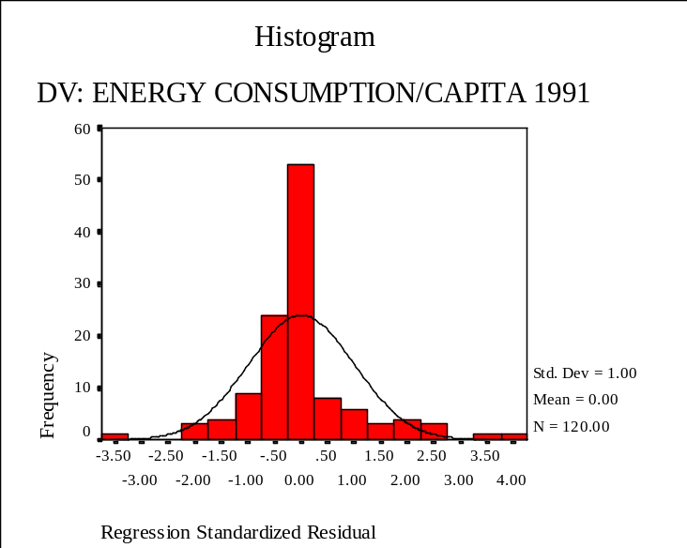
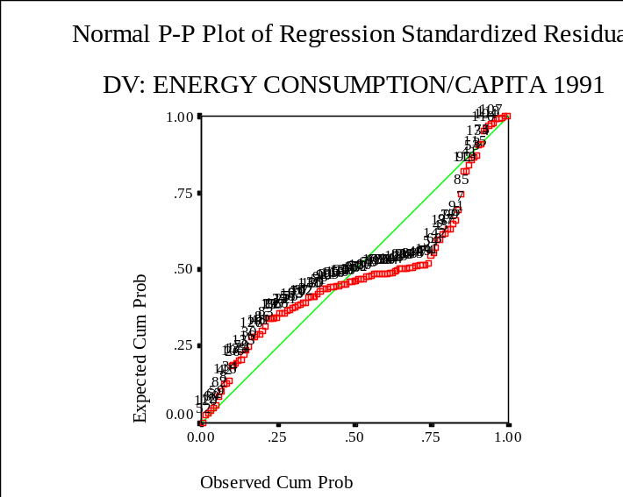
V254, Real GDP/Capita 1991, was regressed on V12, Energy Consumption per Capita 1991, and an R-square value of .69 was generated with the F-statistic of 265.69 significant at the P<.001 level, as seen in appendix 2 page 7. The histogram of the standardized regression residuals to the DV (below) illustrates a large spike that negatively impacts the normality assessment. The normal probability plot generated a snake like curve representing a negative skew. This curve directly violates the linearity assumption and creates the need for data transformation.
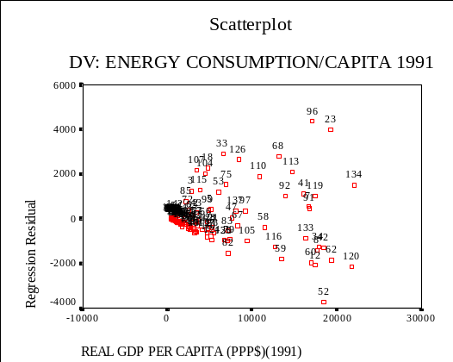
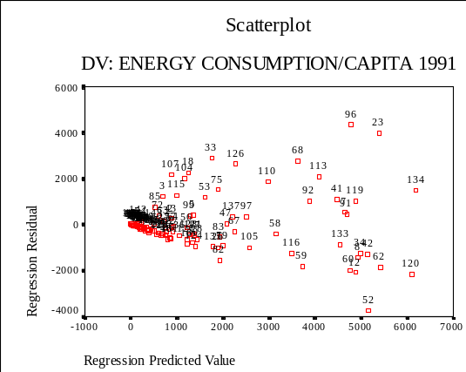
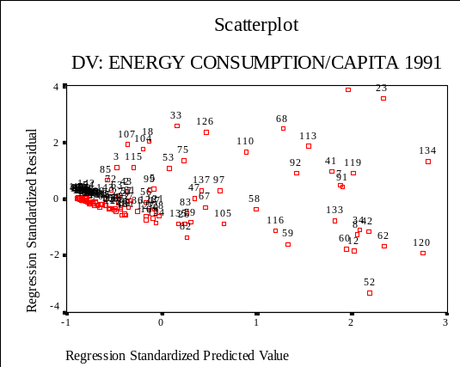
A review of the residual plots generated (below) illustrates normality violations and a small violation in heteroscedasticity. The graph on the left is of the RESID to IV v254 and we see a widening energy usage as GDP increases. The middle graph of the RESID to PRED value shows a slight violation of heteroscedasticity and a general failure in normality. The graph on the right of the ZRESID to ZPRED more clearly illustrates the

issue with normality. As a result of this, a natural log of V12 was performed because of the snaked line rising to the upper left in the normal probability plot and the right skewness present in the histogram graph of this variable, as seen in appendix 2, page 11. The following code was utilized to perform the data transformations and run the regression models:
REGRESSION
/VARIABLES= V12 V254 (or NV12NL)
/DEPENDENT=V12 (or NV12NL)
/METHOD=ENTER V254
/RESIDUALS=DEFAULTS ID(V1) OUTLIERS (ZRESID COOK)
/SCATTERPLOT (V12 V254) (*RESID V254) (*RESID *PRED) (*ZRESID *ZPRED).
GRAPH
/HISTOGRAM(NORMAL)=V12.
COMPUTE NV12NL=LN(V12).
GRAPH
/HISTOGRAM(NORMAL)=NV12NL.
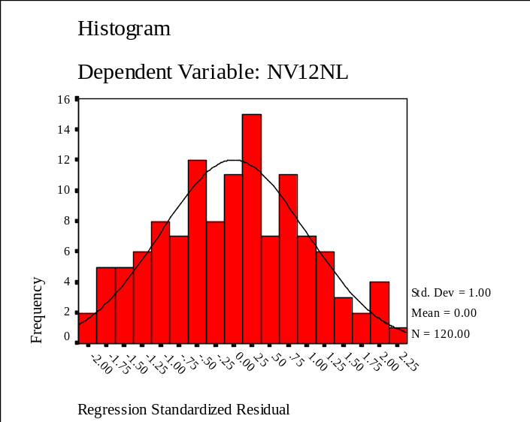
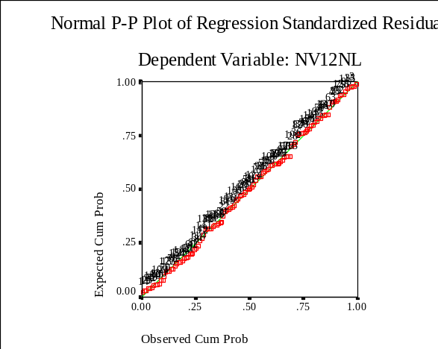
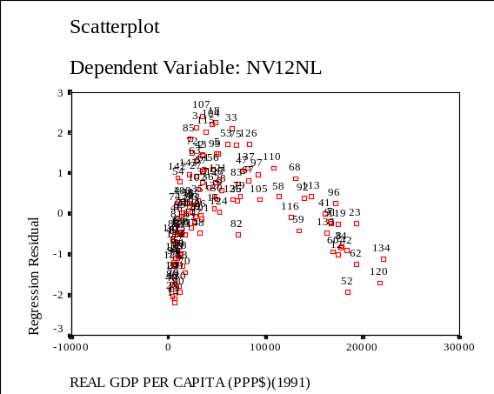
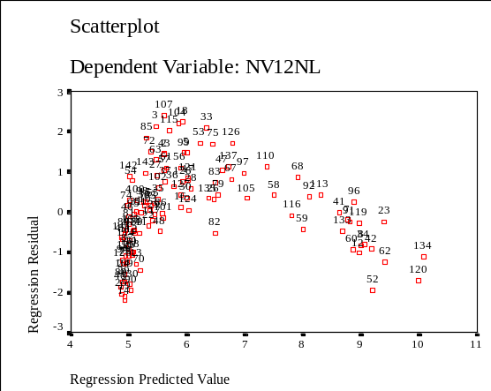
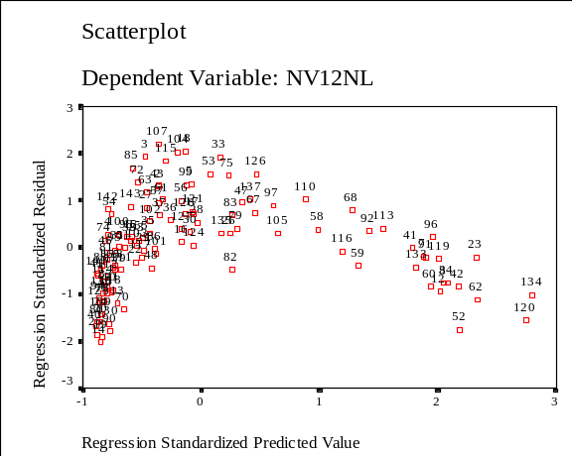
The R-square decreased from .69 to .63 when the IVs were regressed on the natural log of V12. This was a small price to pay for increasing linearity and normality in the model. The following histogram and normal probability plots illustrate the decreased violations as compared to the prior page’s graphs. However, a review of the residual plots generated indicates violations in normality, linearity, and heteroscedasticity, seen below. As such the IV was also transformed log-rhythmically because of the presence of a right skew instead of a straight line in the histogram IV V254, seen somewhat below and in appendix 2 pg 15.

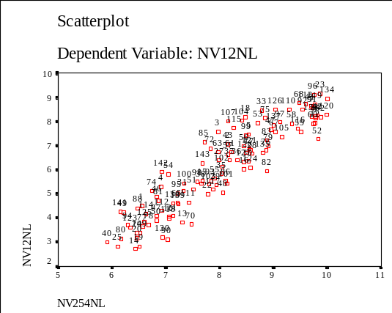
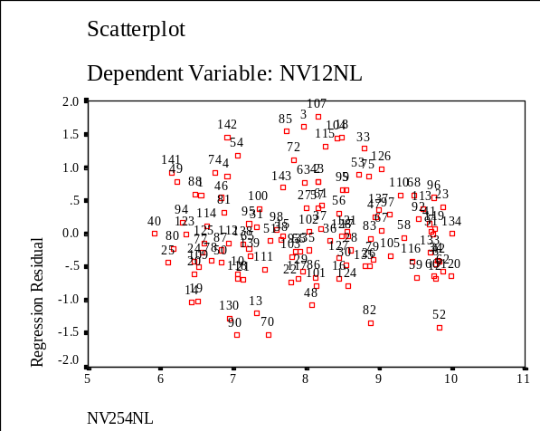
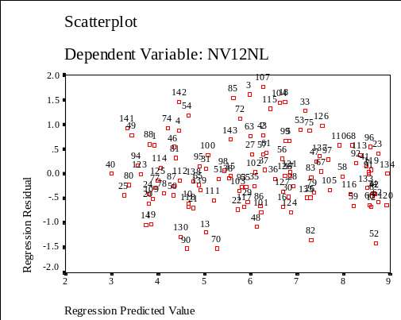
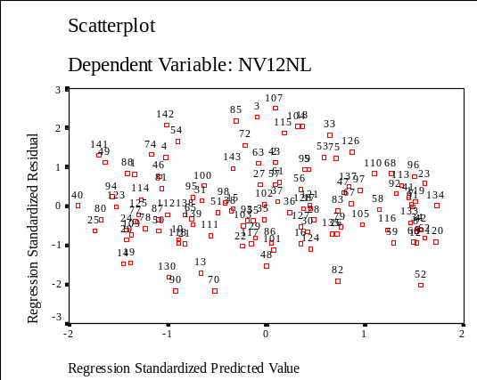
When both the IV and DV were transformed, an R-square of .85 was generated with significance at the P<.001 level, as seen in appendix 2 page 17. The histogram and normal probability plots looked good in regards to the normality and linearity assumptions, as seen in appendix 2 page 18. The following residual charts illustrate that prior violations in the variables have been resolved, but now reveals a potential outlier.
Scatterplot of Transformed IV and DV variable
Potential Outlier- v107
Basic Material – Part 5: Removal of Outlier Case
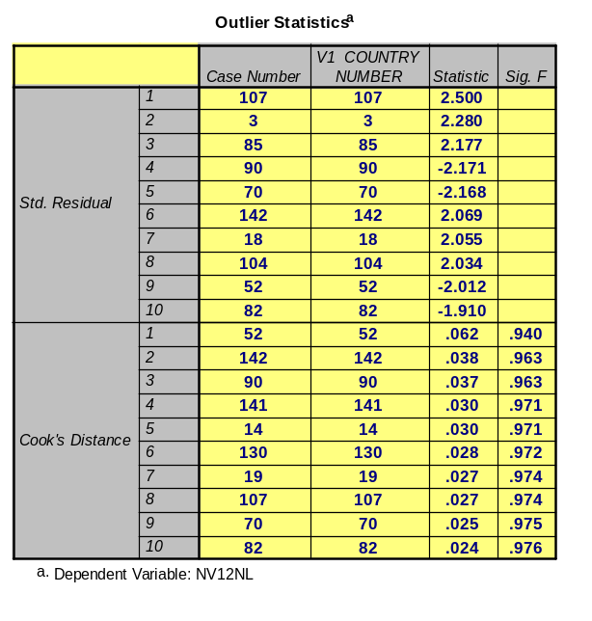
In the first model run the influential /outlier case were countries 96/23. After the IV was transformed it changed to countries 107/120. After both variables were transformed, the influential case was country 107 and the outlier was country 52. The table on the right is the Outlier Statistics table when both variables were transformed.
In review of the Cook’s Distance we find an almost
100% increase from case 142 to 52. This might not be
considered a large enough jump but the case was removed
with the following syntax to illustrate the procedure:
COMPUTE NV1=0
IF (V1=52) NV1=1
REGRESSION SELECT NV1 NE 1
/VARIABLES= NV12NL NV254NL
/DEPENDENT= NV12NL
/METHOD=ENTER NV254NL
/RESIDUALS=DEFAULTS ID(V1) OUTLIERS (ZRESID COOK)
/SCATTERPLOT (NV12NL NV254NL) (*RESID NV254NL) (*RESID *PRED)
(*ZRESID *ZPRED).

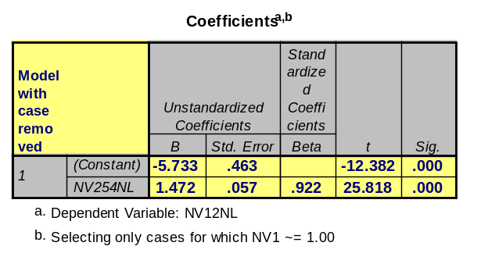
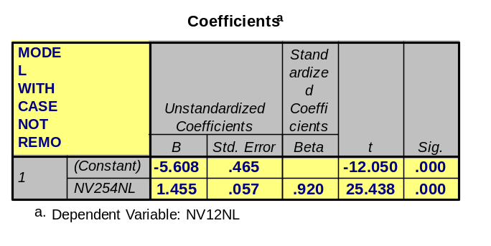
The removal of the case resulted in a negligible increase in R-square. Prior to the removal of the case the R-square was .846 and when the case was removed the R-square was .851. There were also some slight changes in the coefficients but nothing terribly drastic, seen below. The removal of case 52 did not recompute the Cook’s distances such that another case would be considered for removal, as seen in appendix 3 page 23.
Case Not removed
Case removed
Case 107 was identified in the standard residual column of the Outlier statistics as the most influential case. The case was removed according to the COMPUTE procedure listed above. The R-square increased to .857, as seen in appendix 3 page 26. After testing the removal of these cases, I would suggest no removing them as they do not severely impact regression assumptions nor dramatically improve the R-square generated.
Basic Material – Part 6: Quadratic Equations
V143, Contraceptive Prevalence 1980-92, was regressed on V22, Total Fertility Rate 1990, and an initial R-square value of .809 was found with significant coefficients. These variables were reviewed against several quadratic equations for a model fit. The following code was run (note: the following work was performed to satisfy both the basic and advanced material):
COMPUTE NVQ_1A=LN(V143). REGRESSION (2 of 6) REGRESSION SELECT NV1A NE 1
COMPUTE NVQ_2A=NVQ_1*NVQ_1. /VARIABLES= v22 NVQ_1A /VARIABLES= v22 NVQ_1A NVQ_2A
COMPUTE NVQ_3A=V143*V143. /DEPENDENT=v22 /DEPENDENT=v22 (4 of 6)
COMPUTE NVQ_4A=LN(V22). /METHOD=ENTER NVQ_1A. /METHOD=ENTER NVQ_1A NVQ_2A.
REGRESSION (1 of 6) REGRESSION (3 of 6)
/VARIABLES= v22 v143 NVQ_3A /VARIABLES= v22 NVQ_1A NVQ_2A (3 of 6) – IN SYNTAX
/DEPENDENT=v22 /DEPENDENT=v22 (3 of 6) – IN SYNTAX
/METHOD=ENTER v143 NVQ_3A. /METHOD=ENTER NVQ_1A NVQ_2A.
*REVIEW OF MODELS 2,3,4,5 NOTE: OTHER REGRESSION CODES IN THE SYNTAX FOR THIS QUESTION

All regressions run found the results being in line with models and 7 and 10 from H20 according to the numerous coefficients generated, if curious please refer to additional notes in appendix. Model 7, i.e. Y’=a+bln(x) – c[ln(x)]², has its turning point close to IV max and this is the same equation for model 10 but its turning point is close to the IV min. The coefficients for this model, next page, resulted in the turning point being calculated at –2.564/(2*-.726) = 1.767. Considering the range of IV stemmed from 1 to 95 we find the graph of this result to indicate a convex curve, below. A convex curve and a turning point near the min indicates that these results are consistent with model 10, Y’=a+bln(x) – c[ln(x)]². The R-square of this model was .713 with the model and coefficients were significant at the P<.05 level. The variables utilized were not found consistent with any other model.
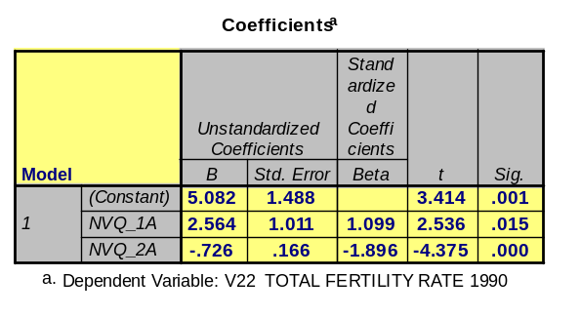

A review of the Cook’s distance statistic found a statistical significant influential case! As such, this variable was removed and the model run again. The result yielded an R-square of .764 which is a good improvement over the prior model’s R-square of .713, and both coefficients were significant at the P<.001 level. However the new constant generated was not significant indicating the value plots below zero, seen below and in appendix 4 page 43.
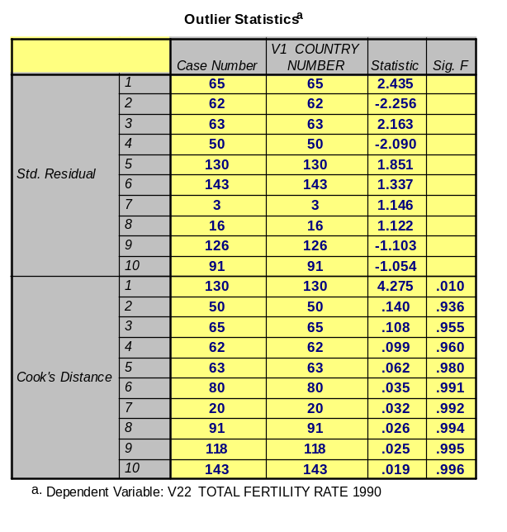
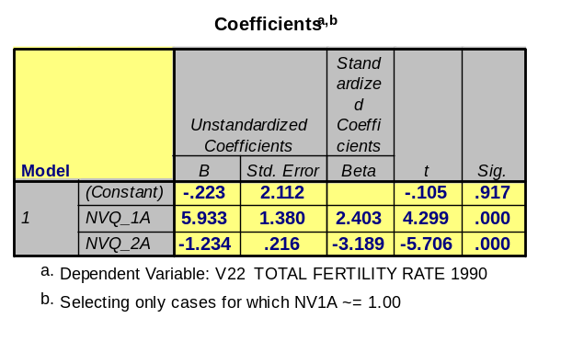
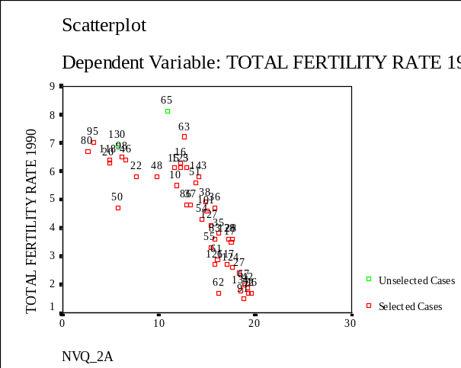
The theory behind this relationship is that countries with high birthrates have low levels of contraceptive use and then there are a few countries with even higher birthrates and contraceptive use but then the slope turns downward yielding with dropping fertility rates and increased contraceptive usage. What could explain this quadratic relationship? Well, if we were to review V159, World System Position, we find nations classified as
Coefficients after v130 removed

peripheral, semi peripheral, and core nations. Nations such as Mali, case 80, Nigeria, case 95, and Uganda, case 130, are all peripheral nations and are found in the graph, prior page, to be those countries with low contraceptive use and high birthrates. This likely results from limited access to contraceptives and different views on child creation. This contrasts with countries like Japan, case 62, and the Netherlands, case 91, who are more industrialized, have increased access to contraceptives, and the people are perhaps less interested in producing large numbers of children because of cost reasons.
Basic Material – Part 7: Statistical Interaction
V47, % Adult Illiteracy Rate 1990, was regressed on V22, Total Fertility Rate 1990, with v254, GDP/Capita 1991 as a moderator variable. The following syntax was utilized to generate the interaction results:
COMPUTE NV_IA=V254*V47.
REGRESSION
/VARIABLES= v22 V47 v254 NV_IA
/DESCRIPTIVES=MEAN STDEV
/DEPENDENT=v22
/METHOD=ENTER v254 V47 NV_IA
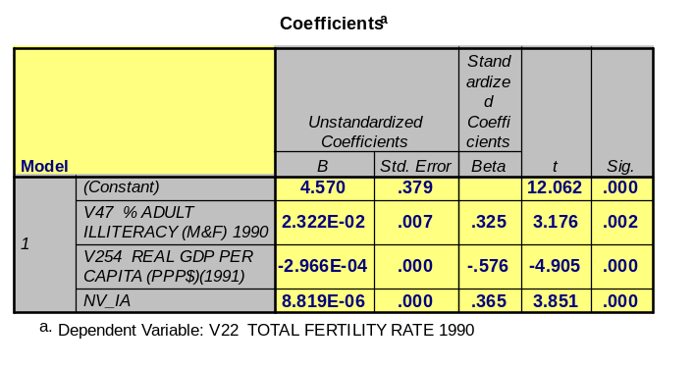
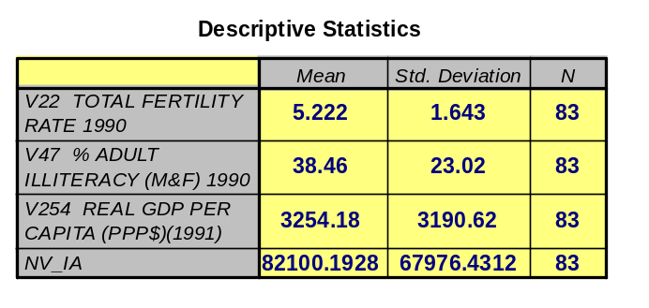
The model resulted in a R-square of .602 and it was significant at the P<.001 level. The coefficients generated, below, were also all significant at the P<.001 level. The medium value of b* was computed with the mean value of the moderator variable (equal to 5610.13) while the of high and low values of b* were computed with the standard deviation of the moderator variable (equal to 3109.62), as seen in appendix 5 page 56.
The values of x²_{low} was (3254.18-3190.62)=144.56, the value of x²_{medium} was 3254.18, and the value of x²_{high} was (3254.18+3190.62)=6363.80. As such, the following equations represent the calculations used to estimate the impact of Adult illiteracy rate on a countries Total Fertility Rate according to low, medium, and high GDP countries.
b*_{low} = (b₁+b₃X₂) = .2322E-02 + 8.819E-06 * 144.56 ] = 0.024
b*_{medium} = (b₁+b₃X₂) = .2322E-02 + 8.819E-06 * 3254.18] = 0.050
b*_{high} = (b₁+b₃X₂) = .2322E-02 + 8.819E-06 * 6363.80] = 0.075

The net effect of adult illiteracy rate (b₁) for a 1 unit change in lower income countries is weaker than the effect for a 1 unit change in high income countries and also weaker than the effect for middle income countries. This suggests that in high income countries, adult illiteracy rate has more influence on a country’s total fertility rate than in middle or low income countries. I am not positive why this would be the case but perhaps it is related to illiterate adults being less attentive to contraceptive usage or less informed. I hypothesized that adult illiteracy would have been more influential on fertility rates in low income countries.
In regards to what happens to the net effects based on the (+) & (-) coefficients generated where b*X₁=(+b₁+b₃X₂)X₁ we see that:
IF (+b₁+b₃X₂)X₁ = a 1 unit increase in X₂ increases the overall net positive value in b*
IF (+b₁-b₃X₂)X₁ = as X₂ increases in strength, b₁ decreases to a point until net affect reverses direction
IF (-b₁+b₃X₂)X₁ = as X₂ increases in strength, b₁ increases to a point until net affect reverses direction
IF (-b₁-b₃X₂)X₁ = a 1 unit increase in X₂ increases the overall net negative value in b*
Basic Material – Part 8: Panel Regression
As cross-sectional analysis was performed with the following variables to predict a countries Total Fertility Rate (note additional work was performed to satisfy both the basic and advanced material):
1980 1990
DV: v224 Total Fertility Rate DV: v86 Total Fertility Rate
IV: v170 Population / Physician IV: v323 Population / Physician
IV: v210 Total Rev as % of GNP IV: v211 Total Rev as % of GNP
IV: v333 % Woman in Labor Force IV: v334 % of Woman in Labor Force
The 1980 model generated an R-square of .535 with F=30.3 significant at the P<.001 level and the coefficients were significant at the P<.01 level, seen on next page and in appendix 6 page 61. As expected, % of women in the labor force was found a negative predictor, albeit small at b=–5.953E-02, and population per physician was found a positive predictor, b=1.019E-04. Total revenue as % of GNP resulted in being a negative predictor where b=-4.246E-02.
The 1990 model resulted in a R-square reduction to .384 with F=10.2 significant at the P<.001 level. The % woman in the labor force remained a significant predictor with only a slight change in the b-value, b=-5.686E-02. Population per physician variable, b=1.085E-04 also remained a significant predictor and it did not reverse direction potentially indicating variable prediction stability over time. The total rev as % of GNP b-value changed dramatically to b=1.056E-03 from b=-4.246E-02 and no longer significant, t=.053. This indicates a lack of reliability in predicting total fertility rate change over time.
When 1990 to 1980 change in the DV was run with the 1980 predictors the resulted in a further R-square reduction to .22 with F=7.428 significant at the P<.001 level. This indicates that the predictors are not adequate in capturing change in the fertility rate over time. The coefficients for the population per physician (b=2.066E-05, t=2.801) and % women in the labor force (b=1.603E-02, t=2.055) were both significant predictors. But, considering the sign reversal for % of women in the labor force and the reduction of the population per physician coefficient from 2.066E-05 vs. 1.085E-04 (1990 model) we find not clear indication of consistency in the predictors. This suggests that the variables utilized are not reliable predictors over time.
The following code was utilized to create a new set of variables representing the 1990 to 1980 change in case values:
COMPUTE PANV_1=V86-V224. REGRESSION
COMPUTE PANV_2=V323-V170. /VARIABLES= PANV_1 PANV_2 PANV_3 PANV_4
COMPUTE PANV_3=V211-V210. /DEPENDENT=PANV_1
COMPUTE PANV_4=V334-V333. /METHOD=ENTER PANV_2 PANV_3 PANV_4.
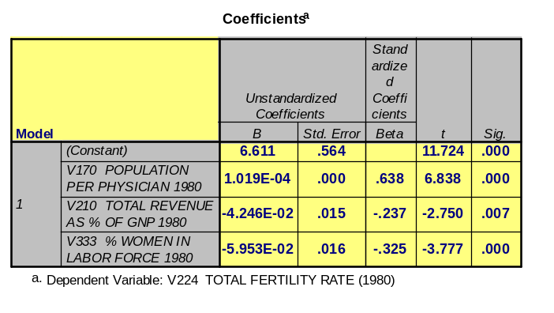
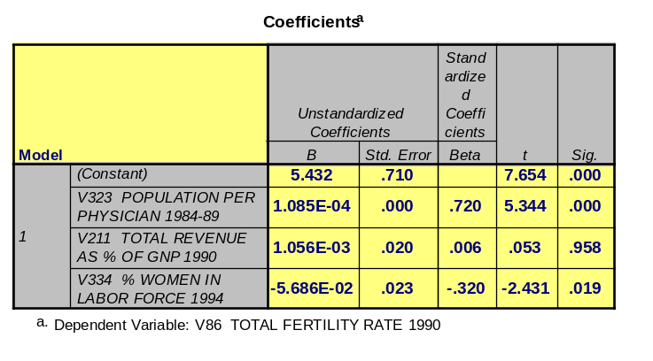
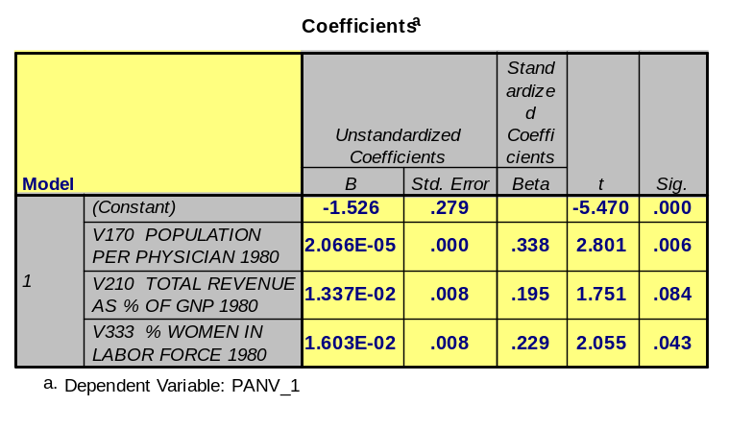
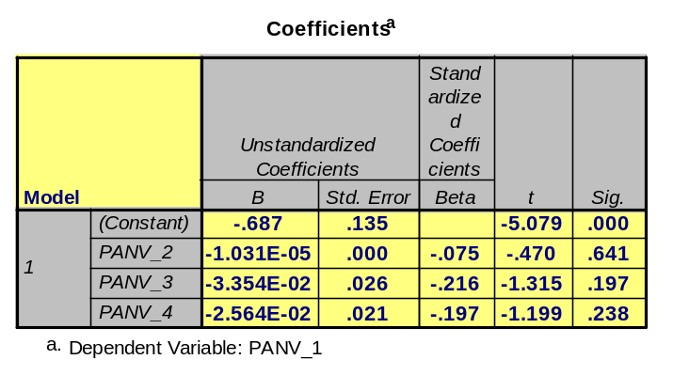
This model resulted in an R-square of .07 with F=.929, Sig=.436, and none of the predictor coefficients being significant. If more work were to be performed in understanding the influences of total fertility rate change over time other variables, or combinations with one or two of the variables utilized in the model would be necessary. The following tables summarize the coefficients for the four models.
1980 Model
R-Square=.535
1990 Model
R-Square=.384
1980 Model wDV change
R-Square=.220
1990 to 80 Model
R-Square=.07
Basic Material – Part 9: Pampel/Williamson/Stryker Article Comments
In short, the article’s hypothesis summarized amounts to the following statment: the influence of class groups increased with corporatism while the influence of aged populations decreased with corporatism in regards to pension spending. Corporatism referred to the level of state sponsored societal negotiation and bargaining over state policy by officially sanctioned organizational representations of business and labor. Pluralism, broadly summarized, referred to countries that did not have state sanctioned participation in guiding pension spending but rather nonhierarchical voluntary groups seeking to influence this kind of policy making. The study developed an interaction analysis to illustrate the differences regarding these classifications. This was done by first applying factor analysis scores to create a country scale. These scale scores were utilized to create a set of dynamic class and age variables that were then applied to two models of pension spending. Ten interaction variables were created from the set of dynamic variables by multiplying one of the designated interaction variables with the other nine designated interaction variables. The first half of each model regressed noninteraction variables on the model’s dependent variable (Pension/GDP or Pensions/Old) while the second half of the model regressed the ten interactive variables on the dependent variable. All the models generated had large R-squares but the models with interaction variables significantly increased the variance explained.
The authors knew which countries were pluralist and corporatist and the interaction terms illustrated percent aged being most influential in the pluralistic societies in that, from the data in Table 2, a one percent increase in percent aged raises pension spending as of percent of GNP by .194. At 1.55 standard deviations, the effect of percent aged fell to .009 while the in pluralistic countries, e.g. United States/Canada, the effect of percent aged nearly doubled from .194 to .349. Thus the interaction terms were based on high, medium, and low scores illustrating the effects of the aged in regards to pension spending by country type. High scores grouped pluralistic while low scores grouped corporatist countries to support the paper’s hypothesis.
Advanced Material – Part 10: More Review of Residual Statistics
Referring back to part 1 we recall that v217, GNP/CAP Growth Rate 1980-91, was regressed on V222, Industrial Growth Rate 1980-1991, and an R-square of .58 was generated with an F-statistic of 57.198 significant at the P<.001 level. The following reviews the additional residual statistics generated, table seen on page 13. An understanding of the following syntax terminology was necessary to generate the residual statistics utilized below: /SAVE PRED ZPRED ADJPRED SEPRED MAHAL COOK LEVER RESID ZRESID SRESID DRESID SDRESID .
The standard error of the predicted value is the estimate of the standard deviation of the average value of the DV for cases that have the same value of the IV. I’m not sure how to utilize this statistic properly nor did I find anything interesting graphically, as seen in appendix 7 page 68-69.
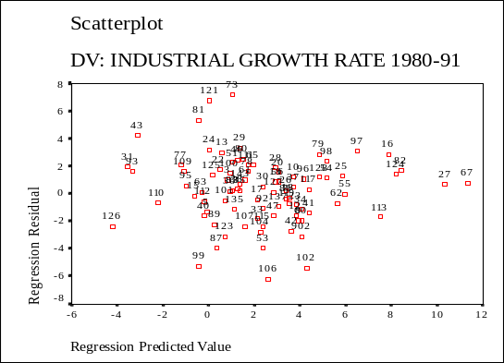
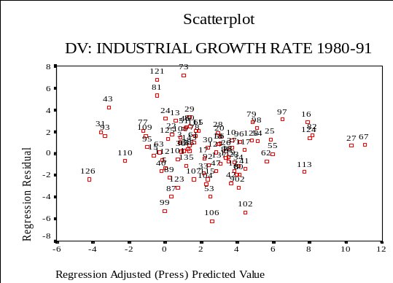
The adjusted predicted value is the predicted value for a case when that case is excluded from the calculation of the regression coefficient. In comparing the min, max, mean, and std. deviation of the predicted values, in the residual tables next page, we find a slight difference in the adjusted predicted values. As such, when we compare the scatterplots of these sets of variables, below, there is really no difference. I imagine that this statistic may be useful in designing custom coefficients.

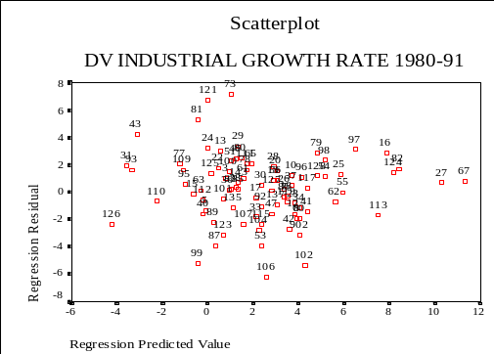
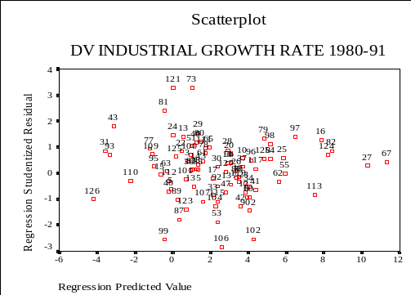
The studentized residual takes the residual and divides it by an estimate of its standard deviation from case to case. This statistic makes it easier to see violations of the regression assumptions (SPSS 9.0 Guide to Data Analysis, pg434). The graph on the left is (*RESID *PRED) while the one on the right is (*SRESID *PRED). Overall we see the same pattern in both of the graphs but the scales of the SRESID graph are smaller. As such, the drawn dotted lines on the right hand graph below do help visualize those cases contributing to the violation of the homoscedasticity better than the graph on the left.

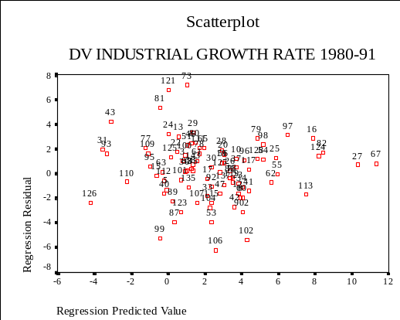
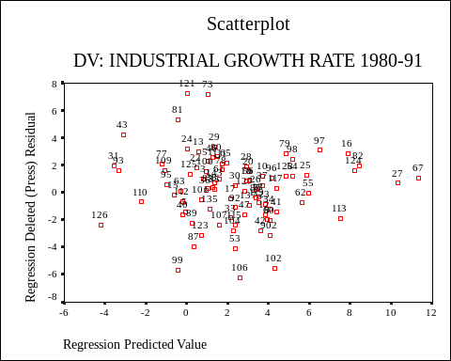
The deleted residual is the residual for a case that is excluded from the calculation of the regression coefficients. In regards to the scatterplots generated there is really no difference in graphs created. The graph on the right is (*RESID *PRED) while the graph on the left is (*DRESID *PRED).

The studentized deleted residual is the studentized residual for a case when that case is excluded from the computation of the regression statistics. Visually it would indicate the impact of a case in the computation of the slope. Considering that I already have some issues with linearity in the data it would be difficult to graph and visualize this difference so its scatterplots were excluded.
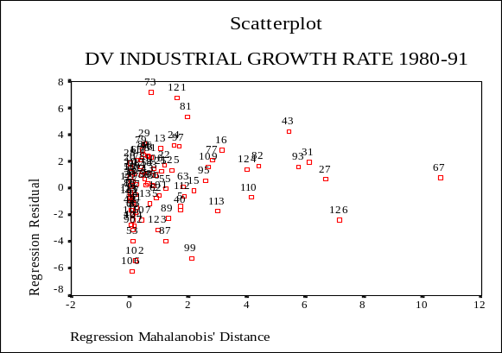
Mahalanobis distance is a measure of how much a cases’ value on the IV differs from the average of all cases. Large Mahalanobis values indicate a case having extreme values on one or more IVs. When this value is plotted against in the RESID value we end up with a scatterplot that visualizes the influential and outlier cases seen in the Outlier Statistics table.

The central leverage value measures the influence of a point on the fit of a regression line.
Advanced Material – Part 11: Question 6 Quadratic Equation Elaboration
All of the models in H20 were performed for this analysis and summarized in the discussion in question 6.
Advanced Material – Part 12: Question 8 Panel Regression Elaboration
All the panel regression models in H21 were performed for this analysis and summarized in the discussion in question 8.

